**Test Plan:**

1. Create a Racer object with the default constructor

2. Create a Racer object with the non-default constructor

(a) with valid field values

(b) with invalid field values

3. Test all the get methods

4. Test all the set methods

(a) with valid arguments

(b) with invalid arguments

5. Test other methods

(a) with valid arguments

(b) with invalid arguments

**Test1: Create a Racer object with the default constructor**

Test data: none

Expected Result: name = "unknown";

        strength = "unknown";

        morality = 0.0;

        cheatPenalty = 0.0;

        strengthBonus = 0.0;

        type = "human";

Acutal Results:

**Test 2: Create a Racer object with the non-default constructor**

1. With valid file values

Test data: name:“xingwen”

Strength:”fastrush“

Morality: 0.5

strengthBonus: 0.05

cheatPenalty: 0.15

type:”computer”

Expected Data: name:“xingwen”

Strength:”fastrush“

Morality: 0.5

strengthBonus: 0.05

cheatPenalty: 0.15

type:”computer”

Actual Result:

1. With invalid file values

Test data: name:“x”

Strength:”fastrush123“

Morality: 5

strengthBonus: 1

cheatPenalty: 1

type:”robot”

Expected Data: name:“x”

Strength:”fastrush123“

Morality: 5

strengthBonus: 1

cheatPenalty: 1

type:”robot”

**Test 3 : Test all the get methods**

1. test the getName() method

Expected Data: “xingwen”

Actual Result:

1. test the getStrength() method

Expected Data: “fastrush”

Actual Result:

1. test getMorality() method

Expected Data: 0.5

Actual Result:

1. test getStrengthBonus() method

Expected Data: 0.05

Actual Result:

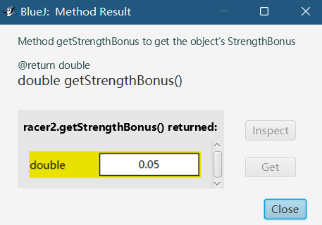

1. test getCheatPenalty() method

Expected Data: 0.15

Actual Result:

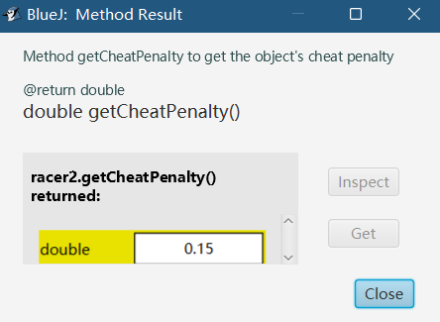

1. test getType() method

Expected Data: “computer”

Actual Result:

**Test 4 : Test all the set methods**

1. test setName(String) method with valid value

Test Data: “newName”

Expected Data: true

Actual Result:

test setName(String) method with invalid value

Test Data: “newName123”

Expected Data: true

Actual Result:

1. test setStrength(String) method with valid value

Test Data: “gogogo”

Expected Data: true

Actual Result:

test setStrength(String) method with invalid value

Test Data: “go”

Expected Data: true

Actual Result:

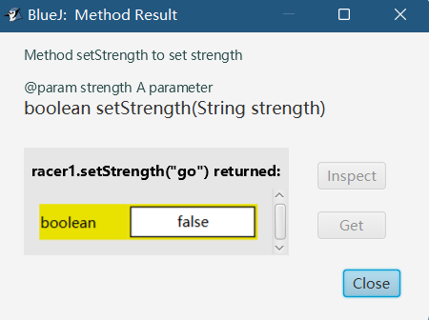

1. test setMorality(double) method with valid value

Test Data: 0.3

Expected Data: true

Actual Result:

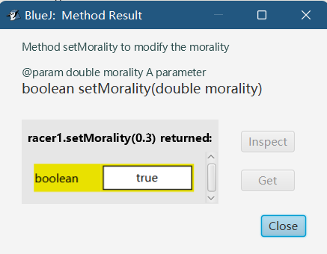

test setMorality(double) method with invalid value

Test Data: 2

Expected Data: true

Actual Result:

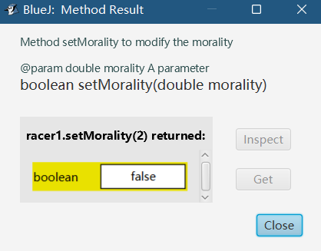

1. test setStengthBonus (double) method with valid value

Test Data: 0.02

Expected Data: true

Actual Result:

test setStengthBonus(double) method with invalid value

Test Data: 0.15

Expected Data: true

Actual Result:

1. test setCheatPenalty(double) method with valid value

Test Data: 0.1

Expected Data: true

Actual Result:

test setMorality(double) method with invalid value

Test Data: 0.21

Expected Data: true

Actual Result:

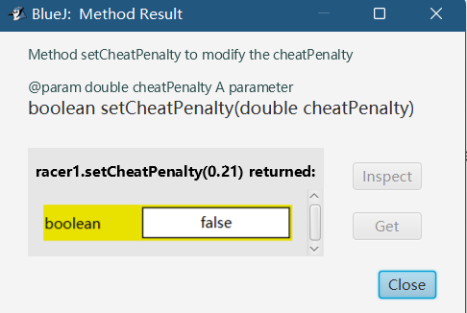

1. test setType(String) method with valid value

Test Data: “human”

Expected Data: true

Actual Result:

test setType(String) method with invalid value

Test Data: AI

Expected Data: true

Actual Result:

**Test 5 : Test other methods**

1. test setNewName() method with valid value

Test Data: “human”

Expected Data: Welcome! Human!

Actual Result:

test setNewName() method with invalid value

Test Data: AI

Expected Data: Welcome! AI!

Actual Result:

1. test setNewStrength() method with valid value

Test Data: rush

Expected Data: Your strength is rush!

Actual Result:

test setNewStrength() method with invalid value

Test Data: abcdabcdabcdabcdabcdabcdabcd

Expected Data: Your strength is abcdabcdabcdabcdabcdabcdabcd

Actual Result:

1. test setNewMorality() method with valid value

Test Data: 0.2

Expected Data: You choose morality of: 0.2

Actual Result:

test setNewMorality() method with invalid value

Test Data: 1.1

Expected Data: You choose morality of: 1.1

Actual Result:

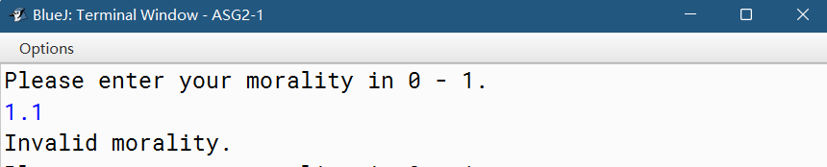

1. test isStringLetter(String) method with valid value

Test Data: test

Expected Data: true

Actual Result:

test isStringLetter(String) method with invalid value

Test Data: test123

Expected Data: true

Actual Result:

1. test toDouble(String) method with valid value

Test Data: 5

Expected Data: 5.0

Actual Result:

test toDouble(String) method with invalid value

Test Data: test123

Expected Data: test123

Actual Result:

